Design Review

Customer Requirement Analysis

Requirement 1 - Add customer details at any point, including: Firstname, surname, DOB, address ect-

RAG Rating - GREEN
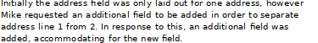
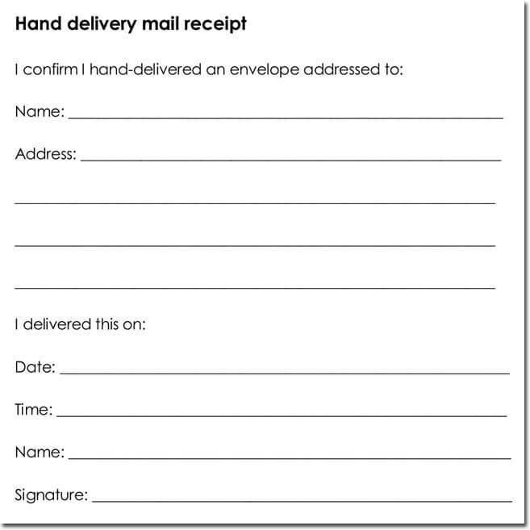
My finalised design does allow me to add customer details at any point, including all of the required fields. Data is inserted into all of the appropriate fields, and replaces missing values with None in the database, allowing Mike to easily identify additional information: such as ‘special need’. As discussed in the design review meeting, additional input fields were also added, to accomodate for multiple address lines.
Another example of additional fields being used to allow a clear separation between addresses can be seen here in this mailing application:

Requirement 2 - Enable the booking of coach trips, including: Destination and number of seats.
RAG Rating - GREEN

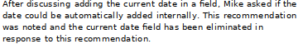
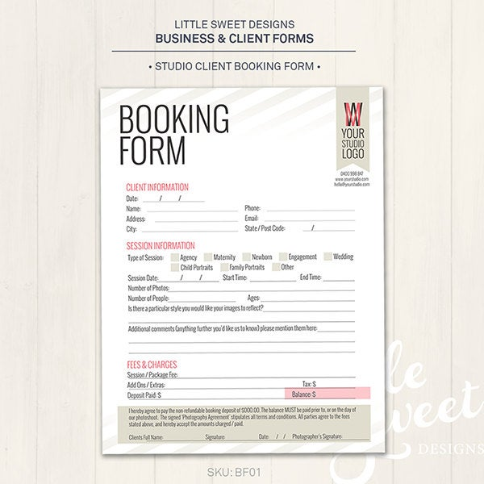
My design will allow Mike to book and manage coach trips, allowing the insertion of all of the appropriate data into the correct fields. Alongside this, Mike and I discussed the removal of the current date field, which has been eliminated and flagged as an unnecessary field. This process will instead be automated, and added into the database as a separate internal command, reducing the chances of human error.

Requirement 3 - Allow silver dawn staff to add trips and events to the database, in order for customers to book. Data stored should include: Duration, dates and cost per passenger.
RAG Rating - GREEN

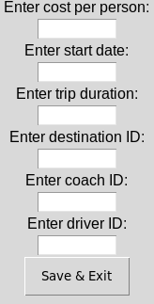
My design allows all of the appropriate data to be entered into the trips table including: trip_id, destination_id, person_cost, EndDate, duration, coach_id and driver_id. All of the foreign keys are used to reduce the number of total fields that contributes to one booking. Alongside this, the database is further normalised to 3rd normal form, improving the overall efficiency and removing data redundancy. During the design review Mike discussed the removal of the end date, in order to further reduce unneeded fields. This has been eliminated, and the trip end is calculated using the start date and duration, as seen here:
Another example of where this can be seen as an intentional design iteration is within this calculation program which uses the same principle, in terms of the calculation:
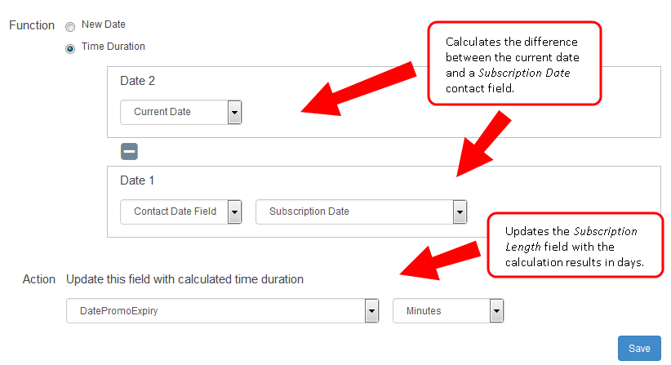

Requirement 4 - Enable silver dawn staff to add destinations.
RAG Rating - GREEN
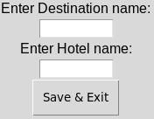
My updated design allows staff to add destinations through the destination window. The destination fields that I have added are: destination name and hotel name with the primary key being automatically incremented with a unique value.
The destination window itself was an iteration, as initially my design integrated this into the trip table, but as discussed before, this has been identified as unoptimised and should be removed and normalized in the database. Another benefit of doing this is that it further improves the visual appeal, making simple tasks clearer to staff.

Requirement 5 - User friendly interface, aimed towards staff and Mike.
RAG Rating - AMBER

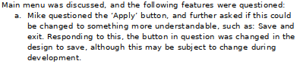

My design partially meets this requirement, with good organisation of fields and buttons and a clear layout in regards to the text labeling each button, however Mike has identified one issue which was the save & exit button alongside the colour scheme. The initial design featured an apply button which was flagged by Mike as necessary and unclear, as seen here in the meeting minutes:

Improvements Based on Feedback

Improvement 1
Save and Exit button - see minutes document titled: ‘Meeting minutes ’, which can be found under the project management folder.

Improvement 2
Additional address fields (field1 and field2) - see minutes document titled: ‘Meeting minutes ’, which can be found under the project management folder.

Improvement 3
Removing current date field, adding it through the system date within the code - see minutes document titled: ‘Meeting minutes ’, which can be found under the project management folder.

